|  |  |  |
| --- | --- | --- |
| **MODULE:** 16 | **LESSON:** 2 | MEAN ABSOLUTE DEVIATION |

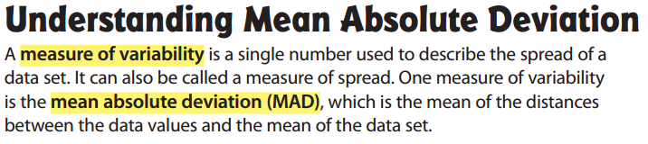

**HOW TO FIND THE MEAN ABSOLUTE DEVIATION:**

